AITHBANK BOD
Fetlar Community Association has taken over the running of the Aithbank Bod for the 2025 season. If you would like to book e-mail FetlarHall@outlook.com or call 07976 714289.
The Bod is camping with a roof and walls so it has very limited facilities. There are two bedrooms:
Room 1 has two x bunk beds. Photo below.
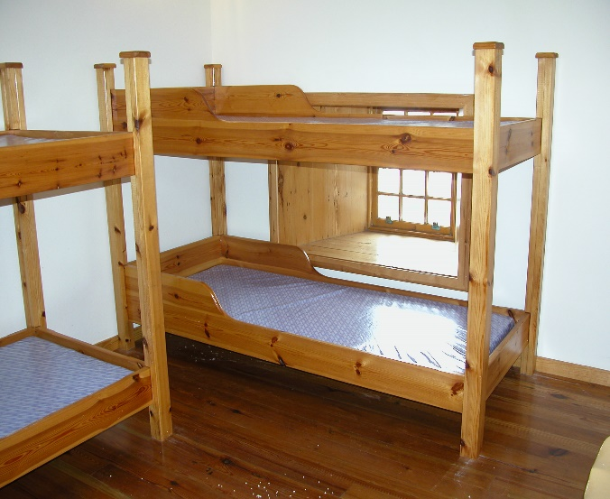
Room 2 has two bunk beds and one box bed. Photo below.
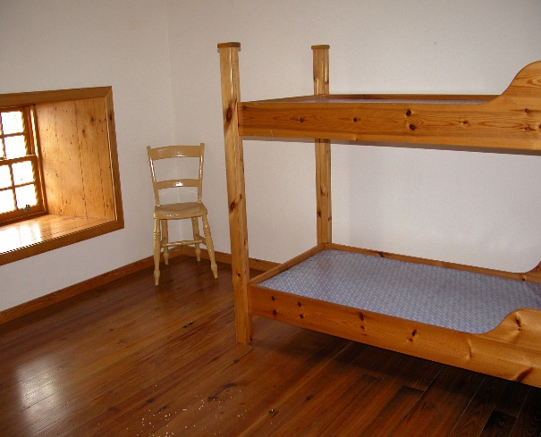
As you can see, all beds have a mattress but nothing else so you will need to bring your own bedding.
The living room downstairs has limited furniture and a fire (which is the only heating provided). You can purchase peat from the shop. Photo below.
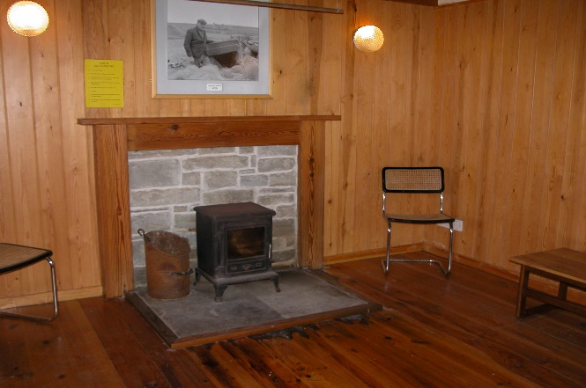
The kitchen has a kettle, an electric ring and limited crockery and cutlery. Photo below.
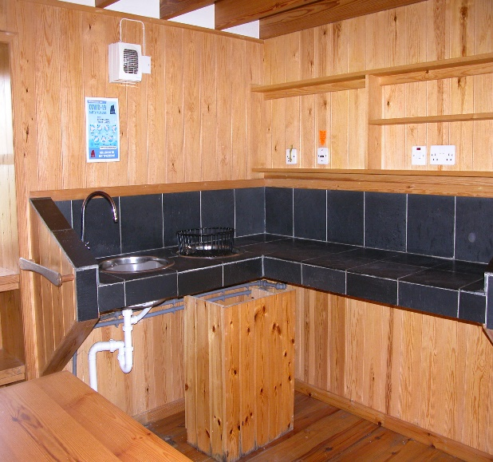
Toilet and washing facilities are in the adjacent byre building. There are two toilets and two showers. Hot water is available but you will need to prime the electric meter (in the cupboard in the kitchen) with £1 or £2 coins before turning on the hot water switch (in the kitchen – labelled).
The cost is £20 per bed per night or £60 per night for Room 1, £40 per night for Room 2, £100 per night to hire the entire Bod.
We cannot guarantee that the Bod will be cleaned after each visitor has left; it is up to all visitors to keep the Bod clean and tidy. There is a mop, brush and dustpan and brush in the porch.

